NAME – Minakshi Sinha

DATE – 15-May-2026

ENTERPRISE BREACH SIMULATION PROJECT REPORT

Title: A Multi-Stage Cyber Attack Simulation Framework for Enterprise Web Applications

1.ABSTRACT
This project demonstrates a real-world enterprise cybersecurity environment using containerized applications, attack simulation tools, and centralized logging systems. A multi-stage cyber attack was simulated on a Docker-based web application (OWASP Juice Shop), including reconnaissance, exploitation, privilege misuse, and data exfiltration. Detection mechanisms such as SIEM logs, Docker logs, and network monitoring tools were used to analyze and mitigate the attack. The project follows MITRE ATT&CK framework for mapping attack techniques and proposes security hardening measures

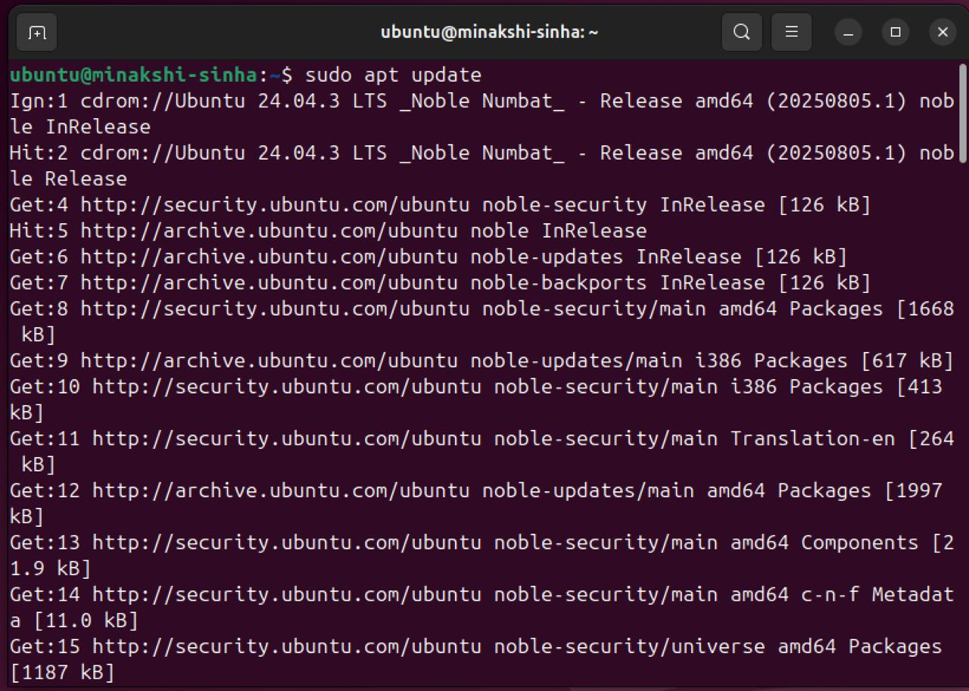

2. INTRODUCTION
Modern enterprises use containerized environments and DevSecOps pipelines, which improve scalability but increase attack surfaces. Cyber attackers exploit vulnerabilities using multi-stage attack techniques.
This project simulates:
- Real enterprise environment
- Attack lifecycle
- Detection and monitoring
- Incident response
- Security hardening
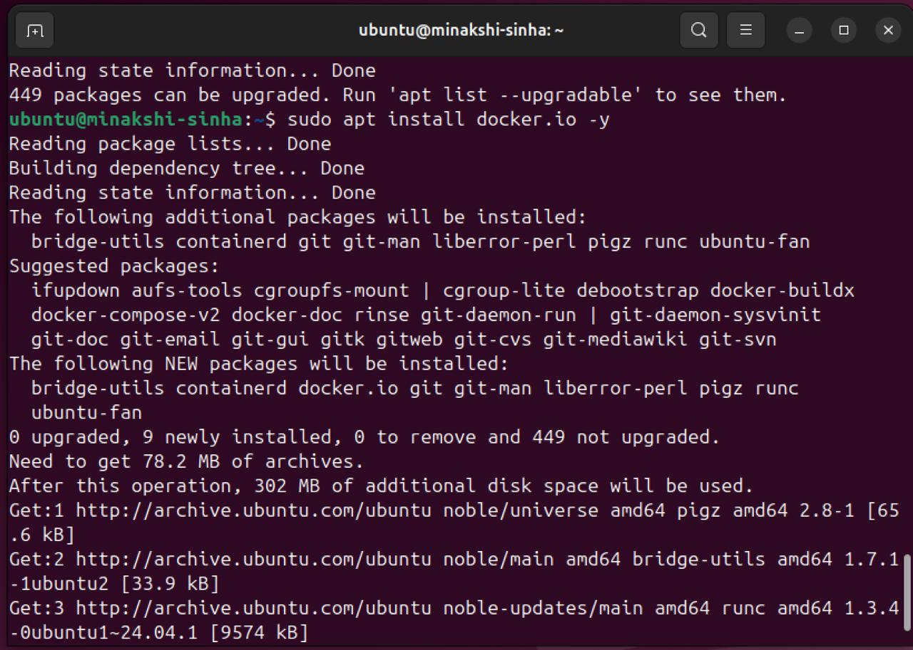

3. OBJECTIVES
- Simulate enterprise-level cyber attack
- Perform vulnerability exploitation
- Monitor attack using logging tools
- Detect malicious activity using SIEM
- Perform forensic analysis
- Implement security hardening

4. TOOLS USED
- Kali Linux (Attacker machine)
- Ubuntu Server (Victim server) de
- Docker (Container runtime)
- OWASP Juice Shop (Target app)
- Splunk (Log monitoring)
- Wireshark (Network analysis)
- Nmap (Scanning tool)
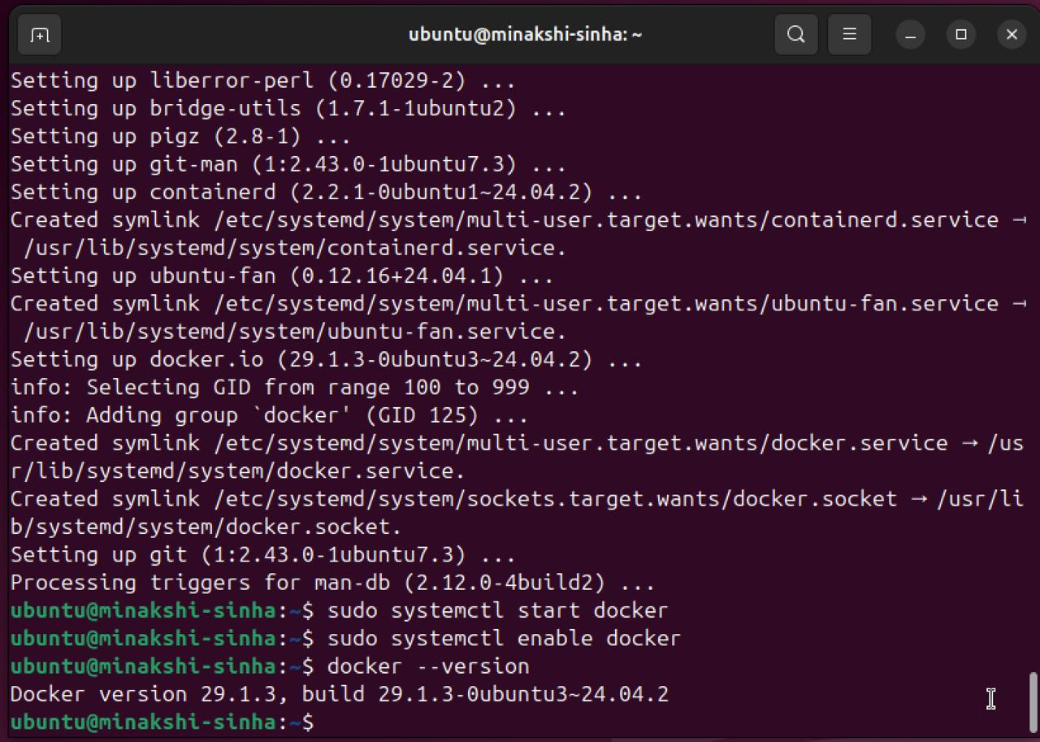

5. SYSTEM ARCHITECTURE
The system consists of:
- Attacker Machine (Kali Linux)
- Target Server (Ubuntu + Docker)
- Web Application (Juice Shop container)
- SIEM System (Splunk / ELK)
- Network monitoring tools

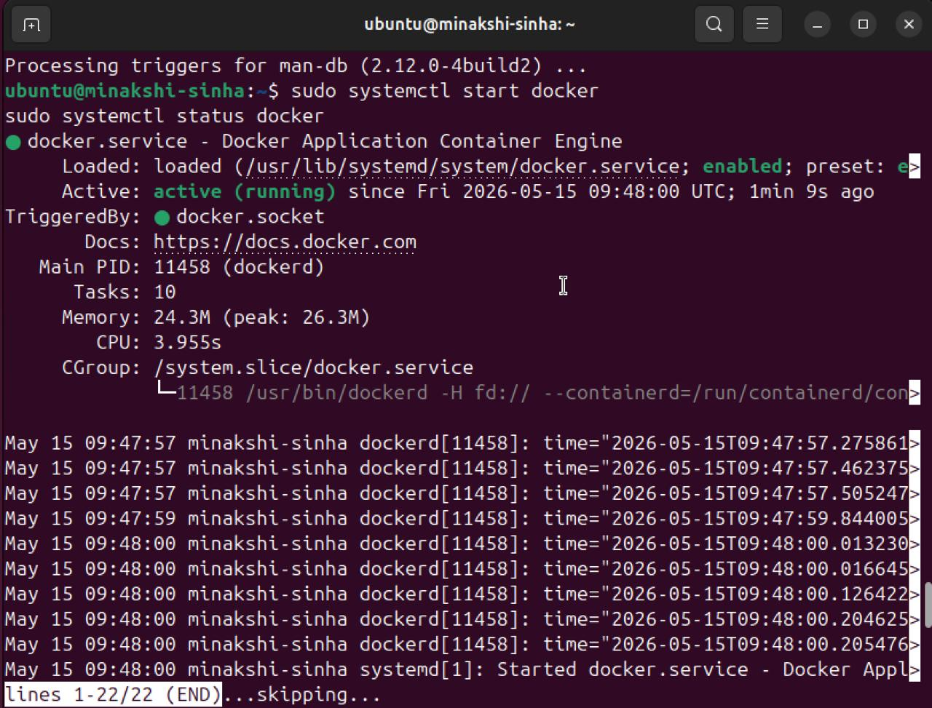

6. IMPLEMENTATION
6.1 Docker Setup
- Docker is installed on Ubuntu server and used to deploy vulnerable web application.
- Sudo docker run -d -p 3000:3000 bkimminich/juice-shop
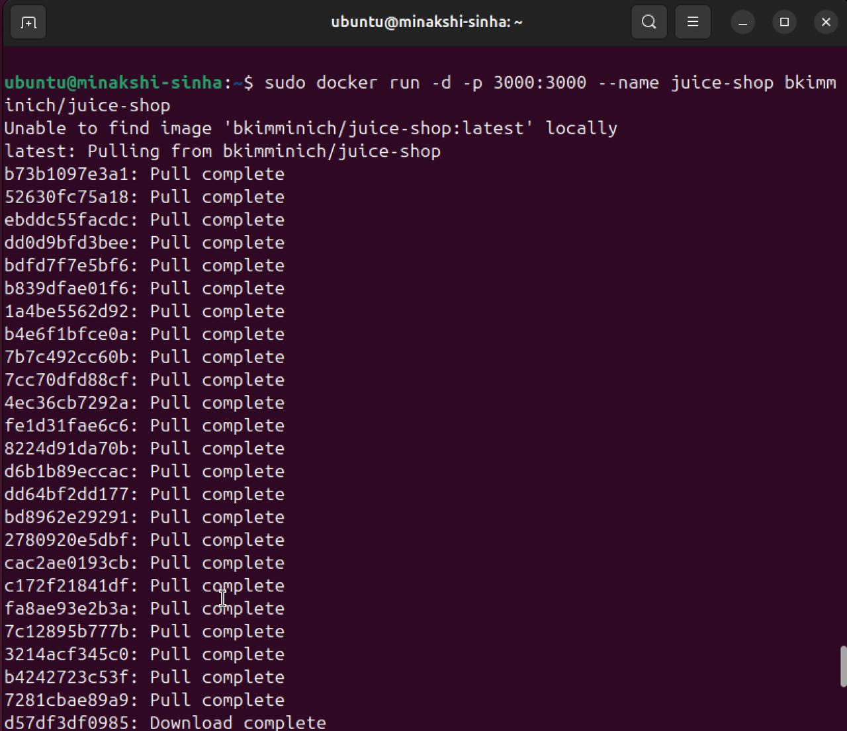

6.2 Web Application Deployment
OWASP Juice Shop is accessed via browser using:
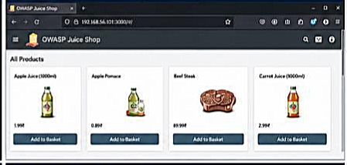
http://<server-ip>:3000

7. ATTACK SIMULATION
7.1 Reconnaissance (Nmap Scan)
Attacker scans open ports and services.
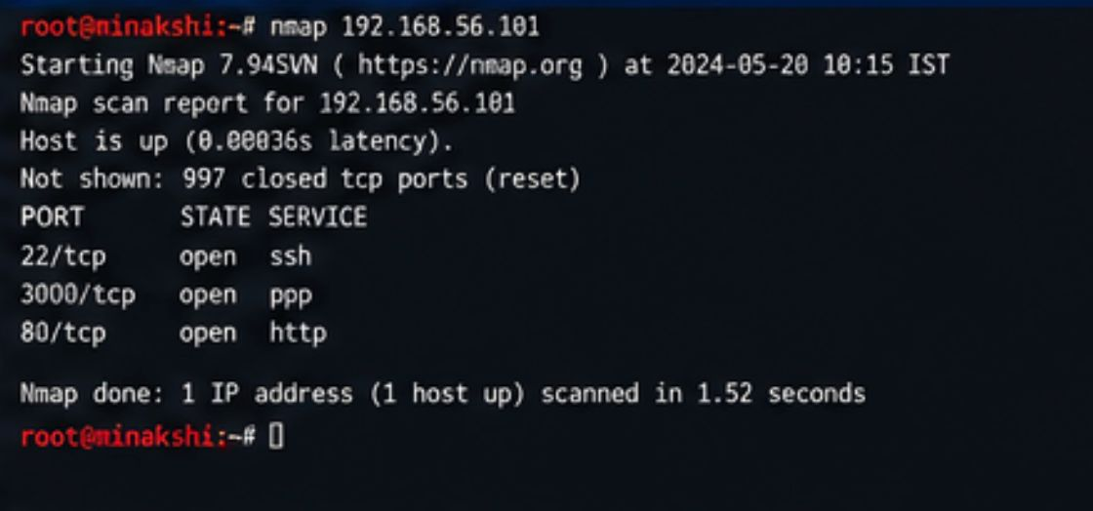
- Nmap scan results

7.2 SQL Injection Attack
Attacker bypasses authentication using malicious SQL query.
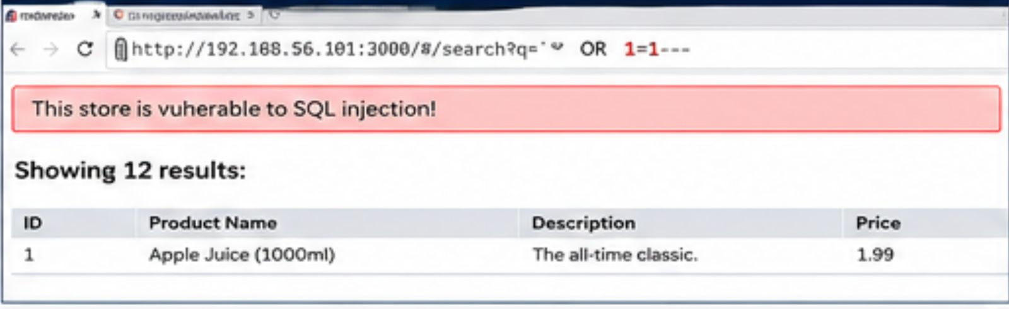
- SQL Injection success page
7.3 XSS Attack
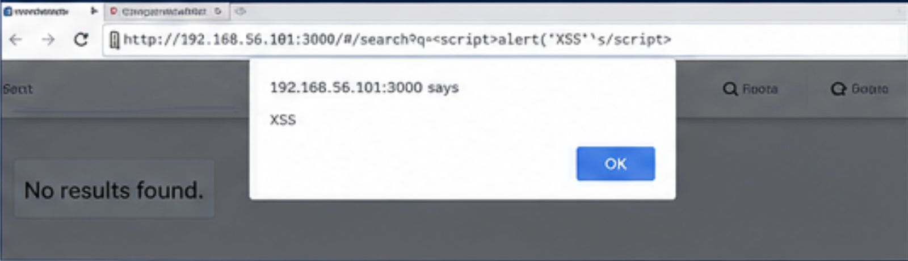
Malicious JavaScript injected into application.
- Alert popup (XSS executed)
7.4 Brute Force Attack
Login attempts using dictionary attack.
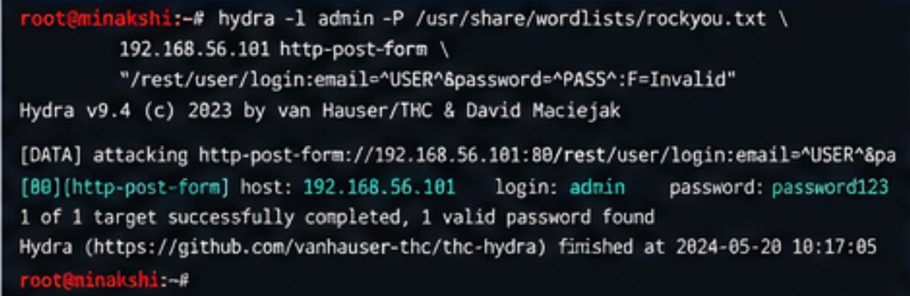
- Hydra or failed login attempts

7.5 File Upload Exploit
Attacker uploads malicious file to server.
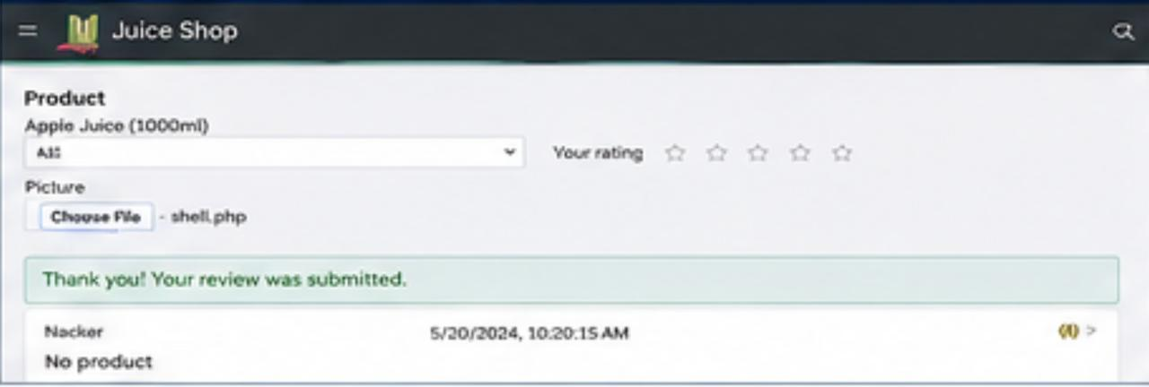
- File upload success screen
7.6 Data Exfiltration
Sensitive data is extracted from system.
- Terminal showing file transfer or extracted data

8. DETECTION & MONITORING
8.1 SIEM Monitoring
Logs are collected and analyzed using Splunk.

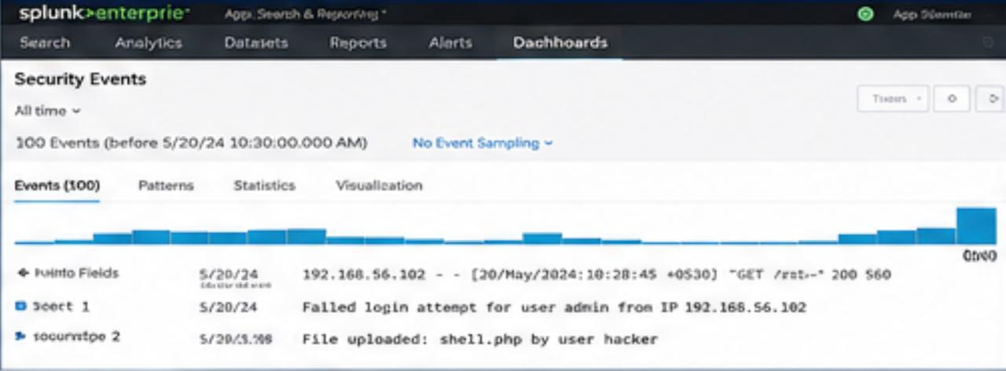
- Splunk dashboard showing events
8.2 Docker Logs Analysis
Container logs show suspicious activity.
8.3 Network Traffic Analysis
Wireshark used to capture malicious traffic.

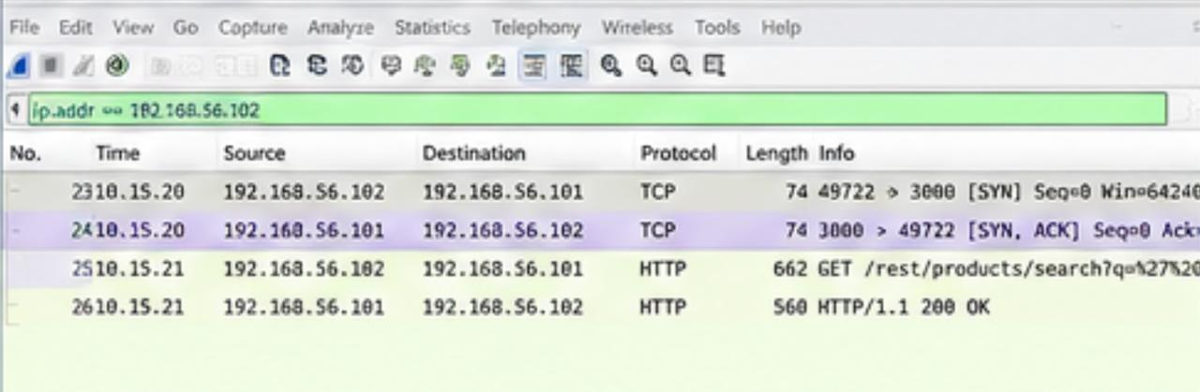
- Packet capture showing HTTP requests

9. INCIDENT RESPONSE
Actions performed:
- Attack detection
- IP blocking
- Service containment
- Log investigation
- System recovery
- Firewall rule applied
- IP blocking (ufw or fail2ban)

10. SECURITY HARDENING
Improvements implemented:
- Firewall enabled (UFW)
- Fail2Ban configured
- Strong authentication policies
- Container isolation
- Log monitoring enabled
- UFW status
- Fail2Ban active status

11. MITRE ATT&CK MAPPING
Phase | Technique
Reconnaissance | Nmap scanning
Initial Access | SQL Injection
Execution | XSS attack
Credential Access | Brute force
Persistence | File upload
Exfiltration | Data theft

12. RESULTS & DISCUSSION
The simulation successfully demonstrated how attackers exploit vulnerabilities in containerized systems and how logs and monitoring tools help detect them. Early detection significantly reduces damage.

13. CONCLUSION
This project shows that modern enterprise systems require:
- Continuous monitoring
- Strong logging systems
- Secure container deployment
- DevSecOps integration
- Zero Trust architecture

